mailto: akayurin@gmail.com

CHANGES LIST
V1.5 06/02/2026
Added option to select Replace/Merge comments from comments table to events table.
If option Replace selected, text in the selected field of events table will be cleared and replaced with text from selected fields of comments table.
If option Merge selected, text from the comments table will be concatenated to text in events table with the specified separator.
This only applies to coupled events. If no corresponding entry in the comment table, the entry will not be changed.
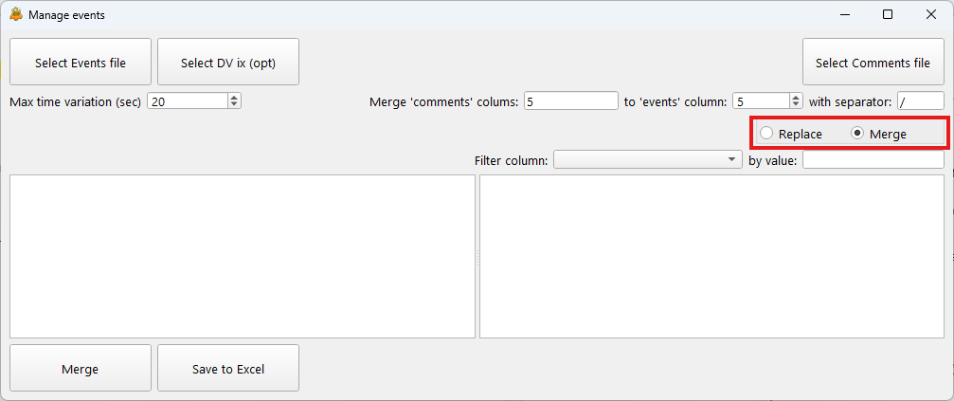

ISPRA EVENT MANAGER v1.4 30/01/2026
ISPRA Event Manager app was developed to help ISPRA personnel in managing DV data navigation and events management.
The purposes of the app are:
- To concatenate camera track and event files from multiple 30 min DV logging sessions into single ‘track’ and ‘events’ files.
- To review, edit on-line events and merge operator’s comments into single file.
- To review digital video and take images if the events.
Digital video was acquired and evented in VisualSoft environment. See typical VisualSoft project structure below.
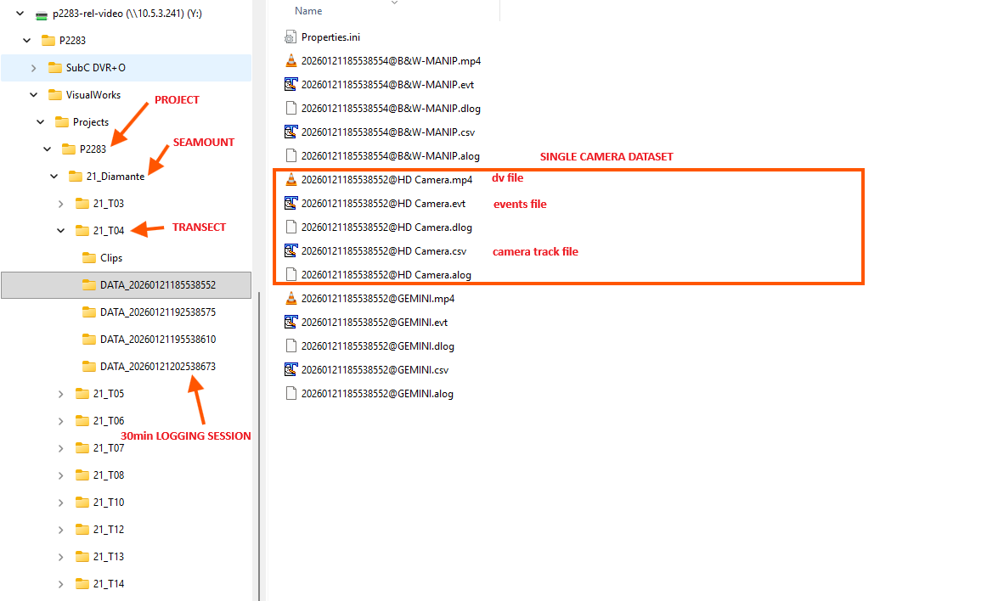
Comments were noted by operator in real time during survey.

MAIN WINDOW
App main window is used for configuration and concatenating sessions into single files and creation of DV index (optional).
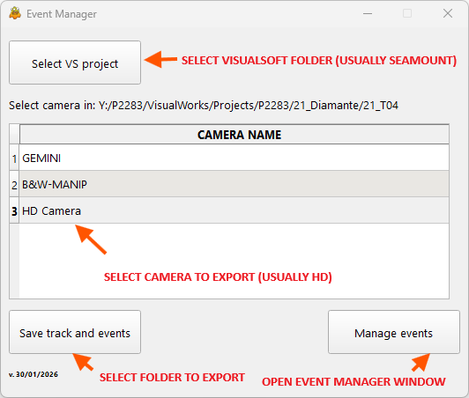
- Select VisualSoft project – normally transect name, any level may be selected though.
- Select camera to export from the list of available cameras.
- Select folder to save exported ‘track’, ‘events’ and ‘dv index’ files.
This will save concatenated ‘track’, ‘events’ and ‘dv index’ (optional) files in Excel format in the selected folder.
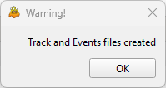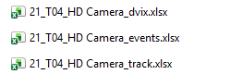
Camera names are parsed by the app based on camera name separator set in configuration file. Normally, the separator is ‘@’. If necessary, it may be changed in configuration file (CAMDELIMITER property).
Option to export ‘dv index’ may be set up in configuration file by setting MAKEDVI property 1 or 0. DV index may only be created if DV available in the project. DV extension may be specified in configuration file by DVEXTENSION attribute. NOTE! If selected, dv index will be created even if DV is unavailable. Actually, the app only reads path of the events files, changes extension and adds to the index. If DV paths changed, those in the index file will become incorrect. In this case you can either reexport files (NOTE! Earlier files will be overwritten if they are stored in the same location under the same names) or change paths manually in the ‘dv index’ Excel file.
Once files are exported, press ‘Manage events’ to open ‘Event Manager’ window.

EVENTS MANAGER
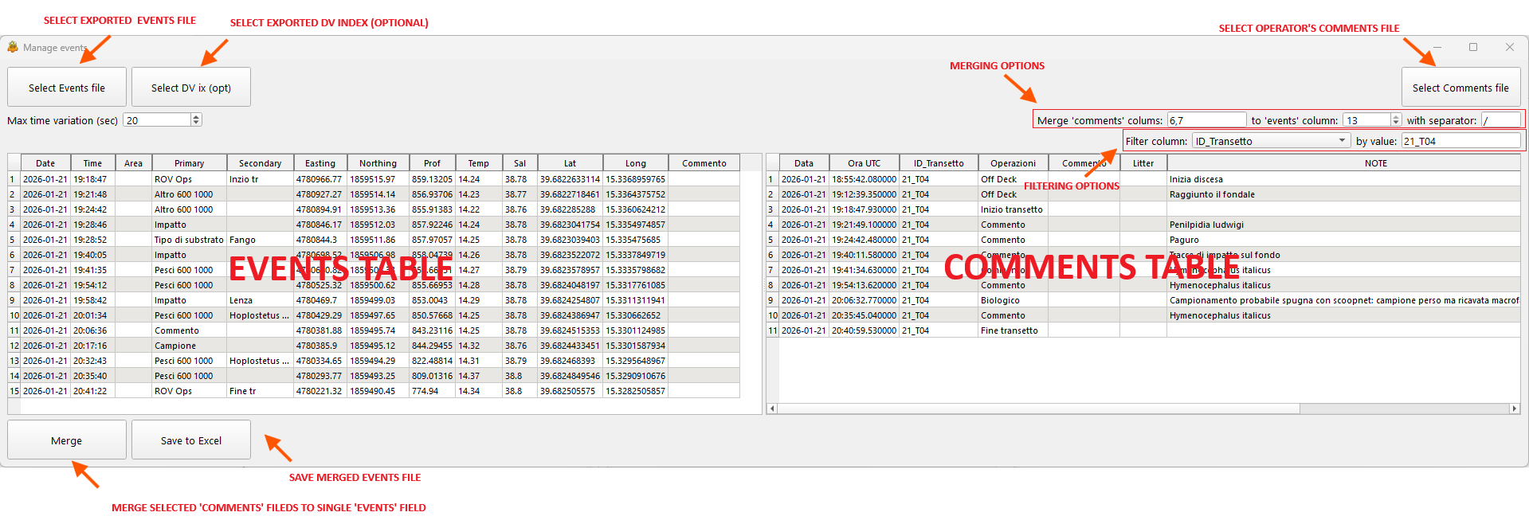
- Select exported events file.
- Select operators’ comments file. ASCII (csv) and Excel formats are presently supported. If Excel format selected, you will be prompted to select sheet name to import. NOTE! Records with corrupted date or time will be ignored.
- Select DV index file (optional). If file selected and DV available on the specified path, Player window will appear.
- Select ‘comments’ fields to merge into ‘events’ table. Multiple fields may be selected. NOTE! In this case the selected fields must be separated by comma, semicolon, space or tab.
- Select field in ‘events’ table to merge comments fields to.
- Select separator for merged comments fields.
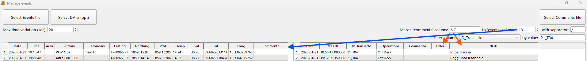
- Select ‘Max time variation’ in seconds.
- Press ‘Merge’ to merge fields FROM comments table TO events table.
- Press ‘Save to Excel’ button to save merged events file. The file will be saved to location of the original events file.
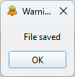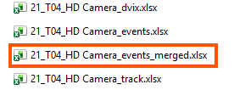
The application will select closest in time comment within specified ‘Max time variation’ and merge selected fields from ‘comments’ table to selected field in the ‘events’ table. NOTE! You may need to adjust ‘Max time variation’ if noted comments are further in time from the logged VisualSoft events.
Note that selected for merging ‘events’ field is editable while all others are read-only. To enable events field editing, change field number in the spinbox.
Typical workflow stipulates adding comments to evens and filling missing ‘Area’ field. To fill ‘Area’ field, select appropriate fields in the events and comments tables and set ‘Max time variation’ to maximum (9999).
Records to show in the comments table may be filtered by column name and value.
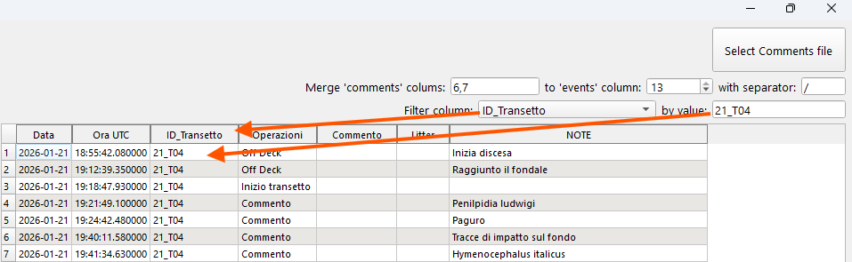

WORKING WITH DIGITAL VIDEO
If ‘dv index’ file is available and digital video exists in the specified in the index locations, you may review video and make screenshots.
If VisualSoft data structure is moved to different location or transferred to another workstation, you can either reexport files or change paths in the ‘dv index’ Excel file manually.
Once ‘dv index’ file selected in the Event Manger window, video player will appear. If DV paths in the index file are incorrect, no video will be loaded to player and the player will remain black.
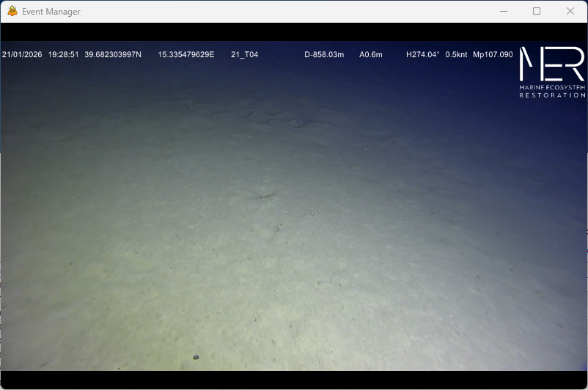
By clicking on event in the event table you can navigate through events.
By scrolling mouse wheel, you can move forward and backward with 0.5 seconds steps.
By pressing ‘Space’ you can take a screenshot of the current view. The screenshot will be saved to location of the selected ‘events’ file. Screenshot name will contain event sequential number and event timestamp.
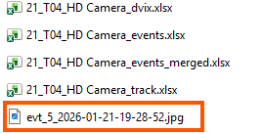

CONFIGURATION FILE
Upon the first app execution, configuration settings are set up internally by the app. Upon app close settings saved next to app executable file in ‘bin’ folder: ./bin/cfg.json.
Next time the app started, the settings will be read from the file. Should the file be missing, the app will use initial settings.
NOTE! It is not recommended to change the file manually. If the config file changed manually and the app cannot start, you need to delete cfg.json file and restart the app.
Although, some settings cannot be changed in the UI, so, you may need to change them manually in the file. See below table of the settings.
PROPERTY NAME | PROPERTY MEANING | DEFAULT VALUE | MAY BE CHANGED IN UI
TRACKEXTENSION | Extension of VisualSoft track files | '.csv' | No
EVTEXTENSION | Extension of VisualSoft events files | '.evt' | No
DVEXTENSION | Extension of VisualSoft digital video files | '.mp4' | No
CAMDELIMITER | Delimiter of camrea name file | '@' | No
TRACKSEPARATOR | Field separator in VisualSoft track files | ',' | No
EVENTSEPARATOR | Field separator in VisualSoft events files | ',' | No
COMMENTSEPARATOR | Filed separator in operator's comments file (csv) | ';' | No
MAXVARIATION | Maximum time variation | 20 | Yes
EVTDATEFIELD | DATE field in VisualSoft events files | 0 | No
EVTTIMEFIELD | TIME field in VisualSoft events files | 1 | No
EVTDTFORMAT | DATETIME format in VisualSoft events files | ['%d/%m/%Y', '%H:%M:%S'] | No
CMTDATEFIELD | DATE field in operator's comments file | 0 | No
CMTTIMEFIELD | TIME field in operator's comments file | 1 | No
CMTDTFORMAT | DATETIME format in operator's comments file | ['%d/%m/%Y', '%H:%M:%S'] | No
ASFDTFROMAT | ASF time format in VisualSoft events files | '%H:%M:%S.%f' | No
MAKEDVI | Create dv index | 1 | No
COMMENTFIELDTOMERGE | Fields to merge from comments table | [6, 7] | Yes
EVENTFIELDTOMERGE | Field to merge to in events table | 13 | Yes
FIELDSEPARATOR | Comments merged fields separator | '/' | Yes

